**LAB PROGRAM 4 (STUDENT FACULTY DATABASE) Name: Tarun Sriram D**

**USN: 1BM19CS171**

**Queries:**

|  |
| --- |
|  |
| CREATE DATABASE student_faculty; |
|  | USE student_faculty; |
|  | CREATE TABLE student( |
|  | snum INT, |
|  | sname VARCHAR(10), |
|  | major VARCHAR(2), |
|  | lvl VARCHAR(2), |
|  | age INT, primary key(snum)); |
|  |  |
|  | CREATE TABLE faculty( |
|  | fid INT,fname VARCHAR(20), |
|  | deptid INT, |
|  | PRIMARY KEY(fid)); |
|  |  |
|  | CREATE TABLE class( |
|  | cname VARCHAR(20), |
|  | metts_at TIMESTAMP, |
|  | room VARCHAR(10), |
|  | fid INT, |
|  | PRIMARY KEY(cname), |
|  | FOREIGN KEY(fid) REFERENCES faculty(fid)); |
|  |  |
|  | CREATE TABLE enrolled( |
|  | snum INT, |
|  | cname VARCHAR(20), |
|  | PRIMARY KEY(snum,cname), |
|  | FOREIGN KEY(snum) REFERENCES student(snum), |
|  | FOREIGN KEY(cname) REFERENCES class(cname)); |
|  |  |
|  | INSERT INTO STUDENT VALUES(1, 'jhon', 'CS', 'Sr', 19); |
|  | INSERT INTO STUDENT VALUES(2, 'Smith', 'CS', 'Jr', 20); |
|  | INSERT INTO STUDENT VALUES(3 , 'Jacob', 'CV', 'Sr', 20); |
|  | INSERT INTO STUDENT VALUES(4, 'Tom ', 'CS', 'Jr', 20); |
|  | INSERT INTO STUDENT VALUES(5, 'Rahul', 'CS', 'Jr', 20); |
|  | INSERT INTO STUDENT VALUES(6, 'Rita', 'CS', 'Sr', 21); |
|  |  |
|  | INSERT INTO FACULTY VALUES(11, 'Harish', 1000); |
|  | INSERT INTO FACULTY VALUES(12, 'MV', 1000); |
|  | INSERT INTO FACULTY VALUES(13 , 'Mira', 1001); |
|  | INSERT INTO FACULTY VALUES(14, 'Shiva', 1002); |
|  | INSERT INTO FACULTY VALUES(15, 'Nupur', 1000); |
|  |  |
|  | insert into class values('class1', '12/11/15 10:15:16', 'R1', 14); |
|  | insert into class values('class10', '12/11/15 10:15:16', 'R128', 14); |
|  | insert into class values('class2', '12/11/15 10:15:20', 'R2', 12); |
|  | insert into class values('class3', '12/11/15 10:15:25', 'R3', 11); |
|  | insert into class values('class4', '12/11/15 20:15:20', 'R4', 14); |
|  | insert into class values('class5', '12/11/15 20:15:20', 'R3', 15); |
|  | insert into class values('class6', '12/11/15 13:20:20', 'R2', 14); |
|  | insert into class values('class7', '12/11/15 10:10:10', 'R3', 14); |
|  |  |
|  | insert into enrolled values(1, 'class1'); |
|  | insert into enrolled values(2, 'class1'); |
|  | insert into enrolled values(3, 'class3'); |
|  | insert into enrolled values(4, 'class3'); |
|  | insert into enrolled values(5, 'class4'); |
|  | insert into enrolled values(1, 'class5'); |
|  | insert into enrolled values(2, 'class5'); |
|  | insert into enrolled values(3, 'class5'); |
|  | insert into enrolled values(4, 'class5'); |
|  | insert into enrolled values(5, 'class5'); |
|  |  |

**Class Table:**

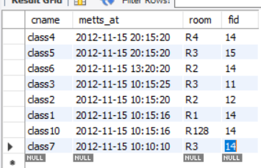

**Enrolled Table:**

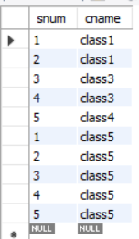

**Faculty Table:**

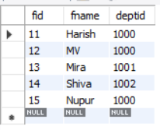

**Student Table:**

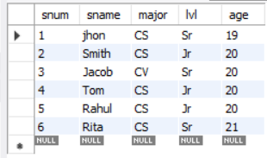

**ADDITIONAL QUERIES**

**Query 1:**

SELECT DISTINCT S.Sname

FROM Student S, Class C, Enrolled E, Faculty F

WHERE S.snum = E.snum AND E.cname = C.cname AND C.fid = F.fid AND

F.fname = 'Harish' AND S.lvl = 'Jr';

**Output:**

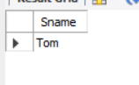

**Query 2:**

SELECT DISTINCT cname

FROM class

WHERE room='R128'

OR

cname IN (SELECT e.cname FROM enrolled e GROUP BY e.cname HAVING COUNT(*)>=5);

**Output:**

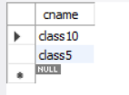

**Query 3:**

SELECT DISTINCT S.sname

FROM Student S

WHERE S.snum IN (SELECT E1.snum

FROM Enrolled E1, Enrolled E2, Class C1, Class C2

WHERE E1.snum = E2.snum AND E1.cname <> E2.cname

AND E1.cname = C1.cname

AND E2.cname = C2.cname AND C1.metts_at = C2.metts_at);

**Output:**



**Query 4:**

SELECT f.fname,f.fid

FROM faculty f

WHERE f.fid in ( SELECT fid FROM class

GROUP BY fid HAVING COUNT(*)=(SELECT COUNT(DISTINCT room) FROM class) );

**Output:**



**Query 5:**

SELECT DISTINCT F.fname

FROM Faculty F

WHERE 5 > (SELECT COUNT(E.snum)

FROM Class C, Enrolled E

WHERE C.cname = E.cname

AND C.fid = F.fid);

**Output:**

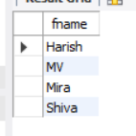

**Query 6:**

SELECT DISTINCT S.sname

FROM Student S

WHERE S.snum NOT IN (SELECT E.snum

FROM Enrolled E );

**Output:**

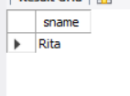

**Query 7:**

SELECT S.age, S.lvl

FROM STUDENT S

GROUP BY S.age, S.lvl

HAVING S.lvl IN(SELECT S1.lvl

FROM STUDENT S1

WHERE S1.age=S.age

GROUP BY S1.age, S1.lvl

HAVING COUNT(*) >= ALL (SELECT COUNT(*)

FROM STUDENT S2

WHERE S1.age=S2.age

GROUP BY S2.lvl, S2.age))

ORDER BY S.age;

**Output:**

